
Submitted By:
Umair Umar CE-25-107
Assignment:
CA Lab No. 5
Submitted To:
Mr. Mehmood
For the fulfillment of,
Circuit Analysis Lab
Department of Computer Engineering
University of Engineering and Technology, Lahore

Circuit Analysis (Lab5)
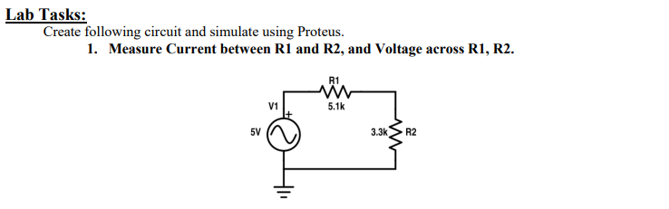
R1 Voltage | R2 Voltage | Current
2.14 V | 1.39 V | 0.42 mA

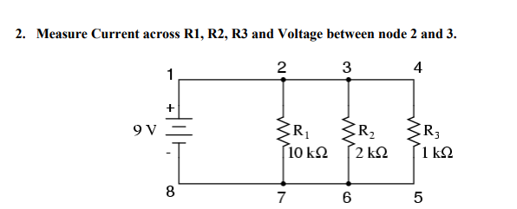
R1 Current | R2 Current | R3 Current | Voltage (node 2–3)
0.9 mA | 4.5 mA | 9.0 mA | 0 V

